Chapter 3 Research Design and Methodology
This chapter tells the examiner HOW the research was done, in order to achieve the research objectives.
So it’s about HOW the research objectives were operationalized
The chapter is written in Past Tense and structured using the Wilson Honeycomb Model.
1. Saunders, M.N.K., Lewis, Philip & Thornhill, Adrian, 2019. Research methods for business students 8th ed. Boston : Pearson
https://anglia.primo.exlibrisgroup.com/permalink/44APU_INST/1il1k4/alma999039428002051
2. Collis, J. & Hussey, Roger, 2014. Business research : a practical guide for undergraduate & postgraduate students 4th ed. Hampshire : Palgrave Macmillan https://anglia.primo.exlibrisgroup.com/permalink/44APU_INST/1il1k4/alma998819430702051

3.0 Introduction
Define Research Design. Discuss the importance of using an appropriate research design (Wilson pg. 172)
Use the Honeycomb Model (Wilson 2013) to outline the typical contents of the chapter.

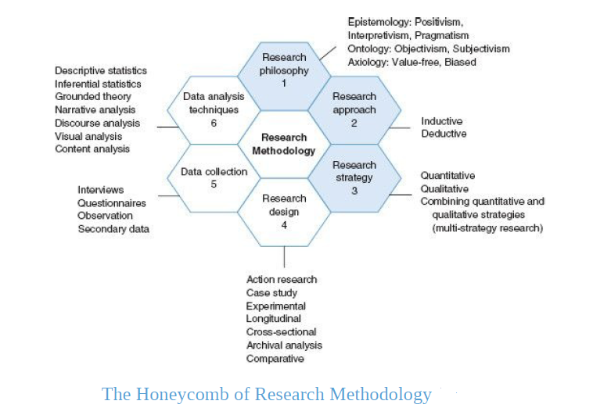

3.1 Research Paradigm (see pg. 36-50 Wilson text)
Define Research Paradigm, use at least 3 authors to do so. Make sure to say at some point in the discussion that one’s paradigm choice is influenced by key philosophical assumptions of Epistemology and Ontology

3.1.1 Research Philosophy
>Start with a discussion of Epistemology- Knowledge and Knowing
Decide on whether you are using a Interpretivism OR Positivistic paradigm OR Pragmatism
> Move on to the idea of Ontology- Reality
Discuss whether your research will be based on an Objective or Subjective stance.
Justify your choices by using literature and apply to your research context.
It might be useful to say why the other cannot work or why it might not be applicable

3.1.2 Research Approach
Define both Inductive and Deductive Approaches
Must discuss whether you are using Inductive or Deductive role of theory
It is important that you justify your choice given the context of your research
It might be useful to say why the other cannot work or why it might not be applicable

3.1.3 Research Strategy
Define Quantitative, Qualitative and Mixed Methods
You must then relate that to whether you are following a Quantitative or Qualitative approach or Mixed Methods
Justify your choices by using literature and apply to your research context.
It might be useful to say why the other cannot work or why it might not be applicable

3.2 Research Design (see pg. 172 Wilson Text)
> Give an overview of type of study i.e. Exploratory, Descriptive, Casual
Chose one, say why and apply to your research context
> State that there are several options to chose from eg: Case study, Systematic Reviews, Netnography
Then say which ONE was used. Write more details- What is it, its strengths and how it was applied to your research.
Use a range of literature sources and remember to apply to your research context.
Must give the time horizon of your research, either Longitudinal or Cross Sectional

3.3 Data Collection (see pg. 264 Wilson text)
Give a brief introduction into the general purpose of data collection in order to achieve the research objectives.
Then clearly state that this research was conducted using secondary data only.
Define secondary data, Discuss the advantage and disadvantage of using secondary data.
Discuss HOW these sources and documents were evaluated for validity and reliability.
Discuss the type of secondary data you used i.e. whether it was internal to an organization or from external sources e.g. Journals, Industry report, government publication, data archive.
Discuss the specific sources/documents that you are using to compile your research findings. E.g. a company case study, published research data etc.
Discuss HOW you searched various databases, discuss the steps. What search criteria was used, how many articles you found etc.
Create a table to list the actual sources used: (this is not your Reference list, but a list of all the key sources for your analysis in chapter 4)
Resource Type | Source
Books  Journals  Company Websites  Professional Bodies  Government Publications | Book 1  Book 2  Etc  International Journal of HRM  Journal of People Resource Mgt  Etc  Amazon.uk  Etc  KPMG  PWC  Ons.gov.uk

3.4 Data Analysis Plan
So you have collected secondary data which may be in a Quantitative e.g. from a survey done by a national body, professional body or from a journal article. You may have also collected Qualitative Data e.g. from a journal article that used interviews to collect data from 20 participants or an interview done by Financial Times or even from YouTube.
How did you analysed it? What techniques did you use? Only discuss techniques actually used.

Quantitative Analysis (see pg. 318 Wilson text)
Discuss the use of Descriptive Statistics- Tables, Distribution Frequencies, Cross Tabulation, Central Tendency (Mean, Median, Mode), Scatter Diagrams, Graphical Forms (Pie, Bar etc.)

Qualitative Analysis (see pg. 378 Wilson text)
Discuss the use of Thematic Analysis and or Content Analysis

3.5 Ethics (see pg. 139 Wilson text)
Define Ethics in Research
Since you used only secondary data there were no ethical issues regarding privacy and confidentiality of the data used. Refer to the Ethics Application Form- Checklist, all question ticked NO.
But there are 2 ethical issues when using secondary data- 1. Plagiarism and 2. Mis-representing the data. So make sure to discuss this and how you will mitigate both.
Additionally, that you completed the Ethics Training, refer to the Ethics Quiz Certificate
You do have

3.6 Limitations to Research Methodology
Every methodology would have some limitations
Discuss the Issues that might affect the quality of the research i.e. Reliability and Validity
So discuss the limitations of using Secondary Data ONLY

